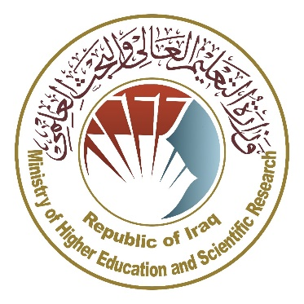
Ministry of Higher Education and Scientific Research
Supervision and Scientific Evaluation Body
Quality Assurance and Academic Accreditation Office

Curriculum for B.Sc. program in Oil and Gas Management and Marketing



Head of Department Assistant Dean for Scientific Affairs

Dr. Rafid Abdul Jalil Majeed Dr. Alla Aldean Abdul Wahab Hassoun

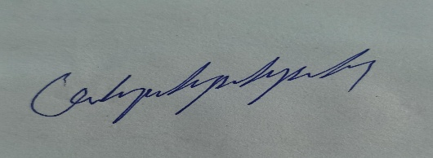

Director of Quality Assurance Unit

A. Lecturer : Wafaa Saeed Hassan

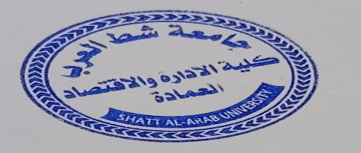

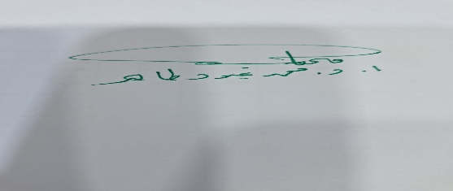

Approved by The Dean of Administration and Economics

Professor Dr. Mohammed Abood Tahir

This course description provides a brief survey of the most important characteristics, expected learning output, showing whether students have made full use f the learning opportunities. These characteristics have to be matched with the description of the program.

1. Educational Institution | Shatt Al-Arab University – college of Administration and Economics
2. Department / Center | Oil and Gas Management and Marketing
3. Course Title | BSc. In Oil and Gas Management and Marketing
4. head of department | Dr. Rafid Abdul Jalil Majeed
5. Number of Teaching Years | 4 years
6. Academic Accreditation | Accreditation for Oil and Gas Management and Marketing
7. Type of Education System | semesters
8. Date f Preparing this program | 1/9/2024

9. Program Objectives
1. Providing a stimulating academic environment to develop students' skills, with the goal of preparing a competent administrative cadre with comprehensive knowledge of the fundamentals of oil and gas management and marketing and their modern applications.
2. Linking theoretical knowledge with practical practices through laboratory experiments and applied projects, ensuring the achievement of the desired educational outcomes for the department's students.
3. Adopting national and international quality standards in evaluating the performance of faculty members, contributing to enhancing the scientific and cognitive competence of faculty members.
4. Instilling professional ethics among students and graduates and enhancing professional integrity, thus protecting them from fraud or manipulation in the workplace.
5. Enhancing academic and research cooperation with scientific institutions inside and outside Iraq, exchanging expertise, and encouraging joint initiatives in the field of research and development.
6. Supporting the initiatives of faculty members and researchers in the department to conduct studies and research that contribute to serving the community and meeting the needs of various state institutions in the field of oil and gas management and marketing

10. Course Output, Methodology and Evaluation
(A) Cognitive Objectives
A-A Cognitive Objectives.
A-1. To enable students to acquire knowledge and understanding of the fundamentals of oil and gas management and marketing, including all management and marketing fundamentals and related problem-solving.
A-2. To enable students to gain a deep understanding of management and marketing related to oil and gas.
A-3. To enable students to acquire knowledge in designing and building successful organizations that operate in accordance with the latest developments in oil and gas management and marketing.
A-4. To enable students to analyze complex technical problems in the field of management and develop alternative solutions.
A-A Cognitive Objectives.

(B) Skill Objectives Related to the Program:
B - Program Skills Objectives:
B-1- Analyze technical problems and find effective solutions.
B-2- Develop software and use modern computing tools for management and marketing.
B-3- Teamwork and cooperation within cohesive work teams.

Methods of Teaching and Learning
1. Academic staff explain the course material using modern interactive tools, such as the smart board and PowerPoint presentations, to present the content in a clear and engaging manner.
2. Assign students homework covering course content, with the aim of consolidating theoretical concepts and enhancing analytical thinking.
3. Encourage students to visit the library to obtain reliable academic resources that support their in-depth understanding of the academic content.
4. Direct students to use educational websites to expand their knowledge and gain up-to-date information on course topics.
5. Develop students' interactive skills by engaging them in class discussions and forming student groups to implement projects or educational activities that stimulate a spirit of competition and teamwork.

Methods of Evaluation
1. Daily tests
2. Classroom assignments
3. Homework
4. Report and seminar preparation

(C) Sentimental and Value Objectives
C-1 - Developing students' sense of professional responsibility and commitment to discipline in performing academic and professional duties.
C-2 - Enhancing commitment to professional ethics and respect for standards of integrity and transparency in engineering work.
C-3 - Instilling the values of cooperation, teamwork, and positive interaction within multidisciplinary teams.
C-4 - Motivating students to adopt a culture of continuous learning and openness to scientific and technological developments.
C-5 - Raising awareness of the importance of respecting intellectual property rights and adhering to ethical behavior when dealing with software and digital resources.

1. Academic staff explain the course material using modern interactive tools, such as the smart board and PowerPoint presentations, to present the content in a clear and engaging manner. | 1. Providing students with the basics and additional topics related to learning outcomes for solving scientific problems.
2. Assign students homework covering course content, with the aim of consolidating theoretical concepts and enhancing analytical thinking. | 2. Solving a set of scientific examples by the academic staff.
3. Encourage students to visit the library to obtain reliable academic resources that support their in-depth understanding of the academic content. | 3. Motivating students during the lecture to solve certain scientific problems.
4. Direct students to use educational websites to expand their knowledge and gain up-to-date information on course topics. | e. Showing practical cases.
5. Develop students' interactive skills by engaging them in class discussions and forming student groups to implement projects or educational activities that stimulate a spirit of competition and teamwork.
Methods of Teaching and Learning

Methods of Evaluation
1. Daily tests | a. Daily quizzes.
2. Classroom assignments | b. Classroom discussions and commitment to ethics and sublime values.
3. Homework | c. Special marks for class activities.
4. Report and seminar preparation | d. Monthly and quarterly evaluation.

D) General and Qualitative Skills (other skills related to the ability of employment and personal development)
a. Enabling students to acquire the skill and art of Oil and Gas Management and Marketing subjects
b. Enabling students to apply creative thinking in operational research
c. Enabling students to use modern methods of analysis and conclusions.
d. Enabling students how to control and leading
11- the program

level | semester | module code | module | cl | Pr |  | lab | sm | tut | sswl | usswl | swl | ECTS
 |  |  |  |  |  | hours per week |  |  |  | hours per semester
year one according to Bologna process | one | MMOG1104  MMOG1102  MMOG1103  MMOG1101  UN115  UN116 | Mathematics  Accounting Principles  Management  Principles  Economic Principles  Democracy and  Human Rights  English Language | 2  3  3  3  2  2 | 1 |  |  | 1  2  1 | 1  1  1  1 | 63  78  93  78  33  33 | 37  97  107  97  17  17 | 100  175  200  175  50  50 | 4  7  8  7  2  2
 | two | MMOG1201  MMOG1202  UN125  UN126  MMOG1203  MMOG1204 | Oil Economics  Oil Accounting  Computer Science Basics  Arabic Language  Oil Management  Statistical Principles | 3  3  1  2  3  2 |  |  | 2 | 2  2  2  1 | 1  1  1  1 | 93  93  48  33  93  63 | 82  82  27  17  82  37 | 175  175  75  50  175  100 | 7  7  3  2  7  4

